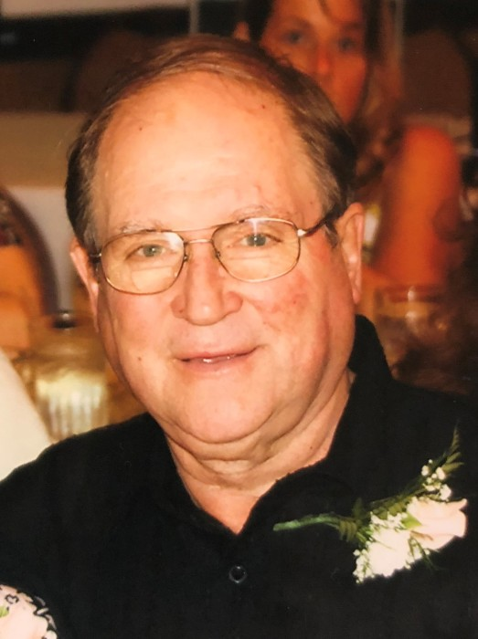
Glen Coalson
Age 80 of Livonia, Passed away peacefully on September 28, 2018. Beloved husband of Pat for 59 wonderful years. Loving father of Glen (Kimberly) Coalson and Karen DuLong. Cherished grandpa of Sarah (Adam) Bigelow, Daniel (Katie) Coalson, Adam DuLong, and Lauren DuLong. Dearest great-grandpa of Grant and Connor Bigelow. Brother of Frances (the late Donald) Prather, Elizabeth (Raleigh) Greenfield, and the late Ronald. Brother in law of Linda. Glen leaves behind many loving family members and friends.
Visitation will take place Sunday, September 30, 2018, 3:00pm-8:00pm, 7:00pm vigil service at Fred Wood Funeral Home-Rice Chapel 36100 Five Mile Rd., (E. of Levan) Livonia.
The funeral Mass will be held Monday, October 1, 2018 at 10:00am, instate 9:30am at St. Colette Catholic Church 17600 Newburgh Rd, Livonia, MI 48152.
In loving memory of Glen memorial contributions may be made to the ALS of Michigan 24359 Northwestern Hwy # 100, Southfield, MI 48075.

