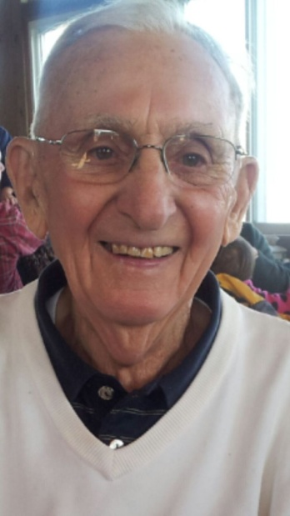
Frank J. Obey, 86, beloved husband of LaVerne (nee Hale), married 63 years; loving father of Vicky Doehring, Becky Obey, Chris Obey (Michelle), Jenny Hartman (Duane), and Tony Obey (Lisa); loving grandfather of Matthew, Rachel, Ben, Brianna, Abby, Liz, Alyssa, Allison, Andrew; dear brother of Bill, Bob and Marie. Passed away Monday, April 25, 2016. He received a BBA from Western Michigan University in 1958, and retired from The Dow Chemical Co. after 30 years of service. He also served on the Board of Directors for the Michigan Minority Business Development Council (MMBDC). He received an "Honorable Discharge" from the U.S. Army and served in the Korean War. In lieu of flowers, memorials may be forwarded to the American Heart Association, 1689 E. 115th St., Cleveland, OH 44106. Memorial service will be held in Newberry, Michigan at a later date. (440)937-6175 www.buschcares.com

