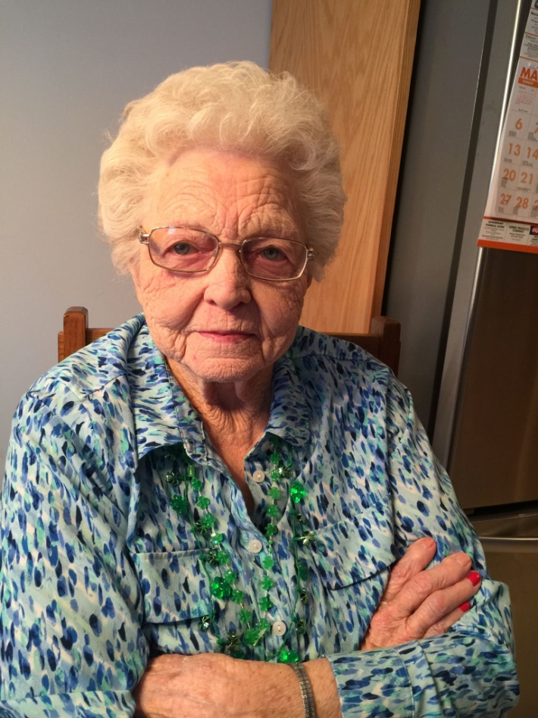

Doris Phillipson Goodrich, age 93, of Munising, died late Sunday morning, July 10, 2016 under the loving care of her family and North Woods Hospice. She was born on October 16, 1922 in Harrietta, Michigan to Fern and Gladys (Rowe) Robinson. Doris attended school in Harrietta and Mesick. While growing up, Doris and her sister were musically talented and entertained the local farmers at the granges and on the radio. She sang, played the guitar and accordion, but Doris’ specialty was yodeling. Doris married Emmett D. Phillipson on November 9, 1940 and in 1941, they moved to Munising. During WWII, Doris worked at the Willow Run Bomber Plant and at Muskegon Motor Specialties Company while Emmett served in the U.S. Air Force. After the War, they returned to the Munising area and began raising their family. After her children began attending school, she went to work at the Deerton School as a cook. Doris and Emmett were married over forty-seven years when he preceded her in death on April 24, 1988.
Doris was a member of the United Methodist Church in Munising, a member of the Order of the Eastern Star and was the oldest living member of Munising Chapter #424, a Life Member and former Commander of the D.A.V. Auxiliary, a Life Member of the American LegioN Auxiliary, a Life Member of the Military Order of the Purple Heart, a member of the Moose Lodge, Life Member of the Michigan Club of Gulf Shores, Alabama, founder of the Lost 20 Girl’s Hunting Club, and a member of the Sno-Riders. Doris served on the AuTrain Township Election Board and also was a 4-H Leader. She married Cecil Goodrich on June 25, 1994 and they were married over eleven years when Cecil preceded her in death on October 5, 2005.
Doris was an avid bowler for over thirty years, an avid hunter and fisherman, and a Life Member of the Bingo Club. She also loved reading the newspaper from front to back, and she enjoyed cheering on the Detroit Lions and Tigers.
She is survived by five children – Ed (Sue Dominick) Phillipson of Shingleton, Jeanie (Dennis) Gramm of Munising, Emmett (Lynne) Phillipson of Grand Marais, Brenda Lindquist of Munising (Rod Merchant of Ithaca), and Sandy (John) Keeler of Harrodsburg, KY; daughter-in-law – Nancy Phillipson; grandchildren – Ed (Kari) Phillipson, Jr., Scott Phillipson, Robin (Brian) Riley, Billy Jack (Amy) Gramm, Nathan (Evi) Lindquist, Laura Young, Melissa Masters, Emmett (Becky) Phillipson, Kimberly (Robert) Watt, Eric (Deidre) Phillipson, Amanda (Tiffany) Phillipson, Brandy (John) DeGrand, Sherry (Terry) Miller, C.J. (Cari) Phillipson, Jessica Olsen, and Jamie Keeler; twenty-five great-grandchildren; two great-great grandchildren; sister – Kathy Witcher of The Colony, Texas; stepson- Charlie (Cheryl) Boom of Pennsylvania; and numerous nieces and nephews. Doris was preceded in death by her parents, infant son in 1942, son Chuck Phillipson on December 4, 2005, husband Emmett, husband Cecil, brothers Ordale and William Robinson, and sisters Genevieve Dennis and Fern Jones.
Visitation will be held at the Bowerman Funeral Home on Friday evening from 5:00 p.m. until 8:00 p.m. and on Saturday from 10:00 a.m. until 10:50 a.m. Doris’ services will begin in the funeral home’s chapel at 11:00 a.m. on Saturday, July 16, 2016. The services will begin with The Order of the Eastern Star service, then the American Legion Auxiliary service, and Rev. Sandra Kolder will conduct Doris’ funeral service. Interment will be at a later date at the Maple Grove Cemetery in Munising. A fellowship luncheon will be held at the American Legion following the services.
Memorials in Doris’ name may be made to North Woods Hospice of Alger County at 129 E. Superior Street, Munising, Michigan 49862.
Her obituary and guestbook may be found at bowermanfuneralhome.net

